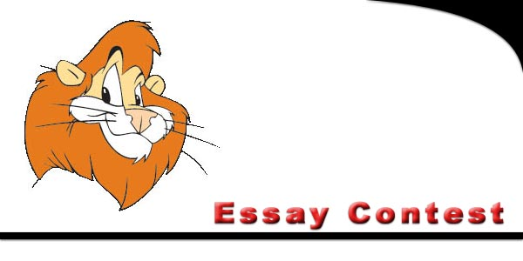

|  |
| --- |
| **Essay Contest Rules** |
| **The Standards Committee of Iowa D.A.R.E. Association has released its rules and guidelines for the 2017 Statewide Student Poster Contest.** |
| **The theme this year is:  "Why I Choose a Drug Free Future"** |
| |  |  | | --- | --- | | **1.** | Open to any fifth or sixth grade student currently receiving the D.A.R.E. program. | | **2.** | No minimum of typewritten words. | | **3.** | **Submit only one essay per school (building).** | | **4.** | Include student's:  name, grade, and school address on the back of the essay. | | **5.** | Also include Officer's name and agency on the essay.. | |  | | |  | |   Mail entries to: **Sara Hendrickson** Decorah Police Department **400 Claiborne Dr. PO Box 1, Decorah, IA 52101**  [shendrickson@decorahia.org](mailto:shendrickson@decorahia.org) All Entries must be postmarked by May 6, 2017 |