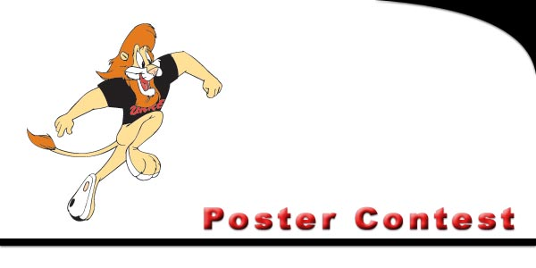

|  |
| --- |
| **Poster Contest Rules** |
| **The Standards Committee of Iowa D.A.R.E. Association has released its rules and guidelines for the 2017 Statewide Student Poster Contest.** |
| **The theme this year is:  "Why I Choose a Drug Free Future"** |
| |  |  | | --- | --- | | **1.** | Open to any fifth or sixth grade student currently receiving the D.A.R.E. program. | | **2.** | Categories:  Creativity, Neatness, Message, Overall | | **3.** | Standard Size Poster Board | | **4.** | Any medium eligible (paint, marker, crayon, etc.) | | **5.** | Submit only two entries per school (building). | | **6.** | Include student's:  name, grade, and school address on the back of the poster. | | **7.** | Also include Officer's name and agency on back of the poster. | | Posters will be submitted at the 2017 I.D.A. Training Conference, **June 25-27, 2017**, in Lemars, Iowa. | |   For More Information: Contact  **Sara Hendrickson** Decorah Police Department **400 Claiborne Dr. PO Box 1, Decorah, IA 52101**  [shendrickson@decorahia.org](mailto:shendrickson@decorahia.org) All Entries must be postmarked by May 6, 2017 |