IMPORTANT INFORMATION REGARDING THE SUCCESSFUL SUBMISSION OF THIS DOT APPLICATION PACKET!

READ ALL OF THE ENCLOSED INFORMATION AND FOLLOW THE DIRECTIONS TO REGISTER AN OFFICER FOR THE CLASS.

Policy 6 and Policy 7 are provided for your review to set forth the requirements for D.A.R.E. Officer selection and training criteria. These policies are to be kept by your agency and are NOT to be submitted with your application packet.

The request for D.A.R.E. training form must be filled out with the training component applied for being marked at the top.

The application form must be filled out in its entirety. Do not forget to include the date of law enforcement certification and A COPY OF THE LAW ENFORCEMENT CERTIFICATE PROVIDED WHEN THE OFFICER WAS CERTIFIED!! Without this proof of certification your application cannot be processed or approved.

The intergovernmental agreement must be completed if your agency is a new program or starting a program in a new school district. If you are already operating an active D.A.R.E. program please note on the form that an agreement is already in place, have your agency head sign it, and include it in the packet.

Please read the attached memorandum for training dates, basic information about the training and address to submit your completed application to.

DUE TO THE FACT THAT THIS TRAINING IS IN HIGH DEMAND, WE RESPECTFULLY REQUEST THAT YOU ONLY REGISTER AND APPLY FOR THIS TRAINING WITH APPROVAL FROM YOUR AGENCY ADMINISTRATOR. REQUESTS MADE FOR TRAINING WITHOUT THIS APPROVAL WILL NOT BE CONSIDERED. IN THE EVENT YOUR OFFICER CANNOT ATTEND BEFORE THE CLASS ROSTER IS FINALIZED AND DEADLINE FOR DROPPING HAS PASSED, PLEASE BE CONSIDERATE AND MAKE IMMEDIATE NOTIFICATION SO THAT ANOTHER AGENCY MAY BE CONTACTED TO UTILIZE THE CLASS OPENING.

By following the above guidelines, you can help D.A.R.E. Iowa provide high quality and efficient training to all attendees. Thanks for your cooperation and assistance in this endeavor.

Page 1

MEMORANDUM

TO: LAW ENFORCEMENT ADMINISTRATORS/OFFICERS

FROM: TERRY DEHMLOW, D.A.R.E. IOWA STATE COORDINAtor

DATE: April 18th - April 28th, 2027

SUBJECT: D.A.R.E. OFFICER TRAINING

D.A.R.E. Iowa is pleased to announce that we are working on the next D.A.R.E. Officer Training that will be conducted by the Iowa Training Team. This training is made available with the support from the Iowa Midwest Counterdrug Training Center located on Camp Dodge in Johnston, Iowa.

D.A.R.E. Officer Training (DOT) is scheduled for April 18th -28th, 2027 at Camp Dodge, Johnston Iowa. This training is an intense, comprehensive and a rewarding experience. Class space is reserved on a first come, first serve basis, so please submit your application as soon as possible. Class size will be limited to 15 Officers. Enclosed are the following documents:

- D.A.R.E. Officers – Requirement and Selection (Policy #6) – Read this policy very carefully. Law Enforcement officers with a minimum of two years’ experience (or with approved waiver if less than two years) are allowed to become certified D.A.R.E. Officers. There is no exception to the policy established by the D.A.R.E. Regional Training Center Advisory Board.

- D.A.R.E. Officer Training (DOT) – Certification Requirements
(Policy #7) – Read this policy very carefully. Supervisors should be aware that all D.A.R.E. Officer candidates would be required to adhere to this policy.

- Intergovernmental Agreement – An Intergovernmental Agreement must be executed between the school superintendent and the law enforcement agency. This Intergovernmental Agreement must be submitted by all new D.A.R.E. law enforcement agencies. (Agencies with an existing D.A.R.E. Program need not submit a new intergovernmental agreement but should fill it out to show that one is already in place and have it signed by the agency administrator.) The signed Intergovernmental Agreement should be returned along with the application for D.A.R.E. Officer Training.

Page 2

- Application for D.A.R.E. Officer Training – All information on the application must be completed by the D.A.R.E. Officer candidate. The D.A.R.E. Officer candidate and the agency head must then sign the application. Failure to complete all the sections will disqualify the candidate and the candidate will automatically forfeit his/her priority for the training.

- Inter/Intra Regional Training Request or Waiver Request – If an officer needs a waiver from the two-year street experience requirement or any other policy waiver, the waiver request needs to be submitted for review and approval. If an officer is attending from outside of Iowa, the inter/intra regional request form must be signed by your state training coordinator for approval and then submitted with the packet. I can get the signature for you if necessary. This single form may be used for either request. If you cannot make contact, I will forward on.

Tuition & Lodging: All Instructional Materials for the two-week training you will use in your classroom will be provided at zero cost. All lodging for the entire training period is provided at no charge. Lodging is also available over the weekend as attendees are encouraged to remain on site so that they may complete any assignments that are due at the beginning of week 2. Attendees are responsible for their own meals and transportation. Lodging is available the Sunday night (Sept. 27th) prior to the start of the class. You must register with MCTC for the free lodging, I will provide that link at the appropriate time.
There will be a mandatory orientation meeting Sunday night to discuss some items of interest prior to class starting Monday morning, (This is subject to change depending on the room we are assigned and availability). All Instructors/Mentors will be staying at Camp Dodge during the training. It is recommended that each of you do so as well. The class is divided into teams and requires evening assignments as part of the team building to ensure your success. You may leave on the weekend. If you intend to commute, please notify us of that at the time of registration, highly discouraged unless living nearby.

To apply for the class, you must submit a completed application packet with proof of law enforcement certification included, ID with Photo.

Candidates will receive further information about the training once they have been selected to attend the training. I am looking forward to your agency’s participation in this D.A.R.E. Officer Training. If you have any questions, please call me at (319) 269-4104 or email: iacop2@mchsi.com

Please return the applications as soon as possible to:

Terry Dehmlow, State Coordinator/Program Administrator
D.A.R.E. Iowa
P.O. Box 76
Denver, IA 50622 or scan and Email to: iacop2@mchsi.com

Professionally yours,

Terry Dehmlow Page 3

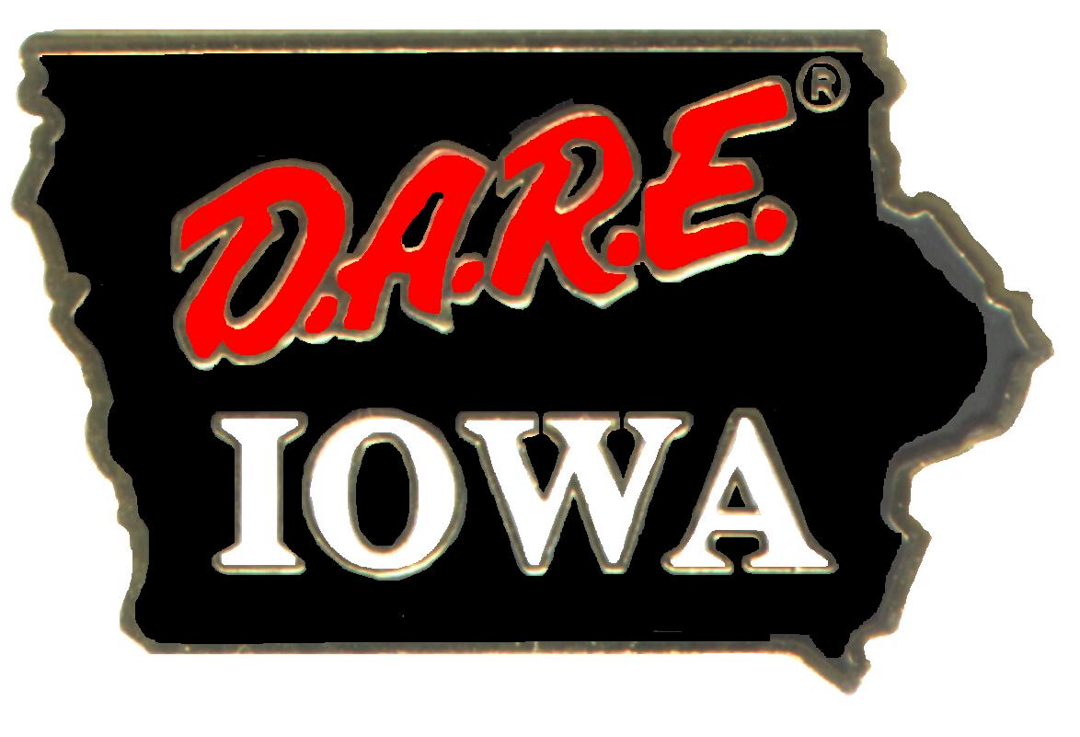
Date: 10/28/26 Policy: 6
SUBJECT

D.A.R.E. OFFICER - REQUIREMENTS AND SELECTION

PURPOSE

The purpose of this policy is to provide guidance to agencies desiring to select potential D.A.R.E. officer candidates.

POLICY

This policy will ensure all candidates applying to receive D.A.R.E. Officer Training (DOT) meet the minimum qualifications for selection as a D.A.R.E. officer. Final acceptance of candidates for D.A.R.E. Officer Training (DOT) will be made by D.A.R.E. Iowa.

DIRECTIVE

1. Certain prerequisites must be met before an individual can be considered to receive D.A.R.E. Officer Training (DOT).

2. The requirements from D.A.R.E. America mandate the individual:

a. be a certified, uniformed peace officer;

b. be a full-time employee;

- have a minimum of two years experience as a certified peace officer working the streets; or
- been granted a written waiver from D.A.R.E. Iowa and the D.A.R.E. America Regional Program Coordinator for out of State Attendance & under 2 years experience.

3. A candidate must meet the minimum standards for peace officer status in the State of Iowa and must fulfill the requirements established by the Iowa Law Enforcement Academy or by the State you are working in.
4. A candidate must submit an application, signed intergovernmental participation agreement and a photocopy of the peace officer training certificate to be considered for D.A.R.E. Officer Training (DOT).

Page 4

5. Before an agency selects an officer to attend the DOT school, it is recommended additional considerations be given to the following:
a. Does the candidate desire to teach children?

b. Does the candidate have a sincere desire to work with children, feel comfortable with them, and is friendly toward them?

c. Does the candidate have good oral and written communication skills?

d. One who refrains from sexual, racial, stereo typing or inappropriate and insensitive remarks.

e. Appearance before an oral panel comprised of at least one educator and one law enforcement officer (preferably a D.A.R.E. officer) may be required to:

1) Evaluate the individual’s experience in making public presentations.

2) Assess the individual’s presentation capabilities (usually done by having the individual make a short presentation before the panel).

3) How much research and practice has the individual done to properly prepare himself/herself?

4) Determine the candidate’s sincere desire.

a) Is the officer just wanting to get off the street?

b) Is the officer really wanting to help reduce drug abuse among young people?

c) Does the officer see this as an opportunity to get recognition and/or a quick promotion?

d) What does the candidate know about the D.A.R.E. program?

e) Does the officer possess good organizational skills?

6. A candidate should project a professional image and have personal habits that are consistent with the role of a D.A.R.E. officer.

7. Agencies may wish to consider additional requirements, such as:

a. Education beyond high school diploma.

b. Minimal sick leave usage.

c. Ethnicity to match the diversity of the community and the schools.

d. Bilingual capabilities. Page 5

Date: 10/28/26 Policy: 7

SUBJECT

D.A.R.E. OFFICER TRAINING (DOT) - CERTIFICATION REQUIREMENTS

PURPOSE

The purpose of this policy is to establish minimum training requirements of an officer to instruct the D.A.R.E. curriculum.

POLICY

The success of the D.A.R.E. program depends largely on the training of D.A.R.E. officers. A carefully designed, comprehensive training course has been developed to prepare officers to deliver the curriculum. The successful completion of this training is required to authorize an officer to deliver the curriculum to students in the elementary school classroom.

DIRECTIVE

1. The D.A.R.E. Officer Training (DOT) shall consist of 80 hours of instruction which is consistent with the current national model.

2. The D.A.R.E. Officer Training (DOT) course is considered the primary duty assignment for attendees. Therefore, strict attendance, academic requirements, dress code, and conduct code will be enforced throughout the course of training.

3. While in attendance, participants will be under the functional supervision of the Training Facilitator. Any serious problems will be reported immediately to the concerned officer’s law enforcement agency.

4. DOT schools will be conducted by D.A.R.E. Mentors who have successfully completed the DOT course and the 40-hour Mentor Officer Training (MOT) course. The Mentor must have successfully completed the shadowing time and be certified by D.A.R.E. America.

5. Upon the approval of the Training Facilitator, specialized instructors (who are non- D.A.R.E. certified) may teach blocks of instruction in which they possess expertise (i.e. classroom management, current drug trends, etc.) during the DOT course.

Page 6

6. Only those individuals who meet the minimum course requirements and successfully complete the DOT course will be certificated. Officers will not be certificated if they miss more than 10 percent of the total course hours. Mandatory attendance at certain blocks of instruction may be required by the Training Facilitator on the advice of the Educational Advisor and with the approval of the State Coordinator. D.A.R.E. Training is very intense and requires hard work and time to complete the assignments. Please avoid or reschedule any court time during the training.

7. In no instance shall an officer be authorized to deliver the D.A.R.E. curriculum without having first been certificated by a recognized D.A.R.E. training center.

8. The DOT course is recognized by the Iowa Law Enforcement Academy as viable law enforcement training.

9. The use of cell phones will be limited to break times and emergencies only.

Page 7

